Name: Ronald Person
Theme: Temperature Converter
GitHub Pages Link: https://github.com/RonaldJPerson/Project-103

Screenshot

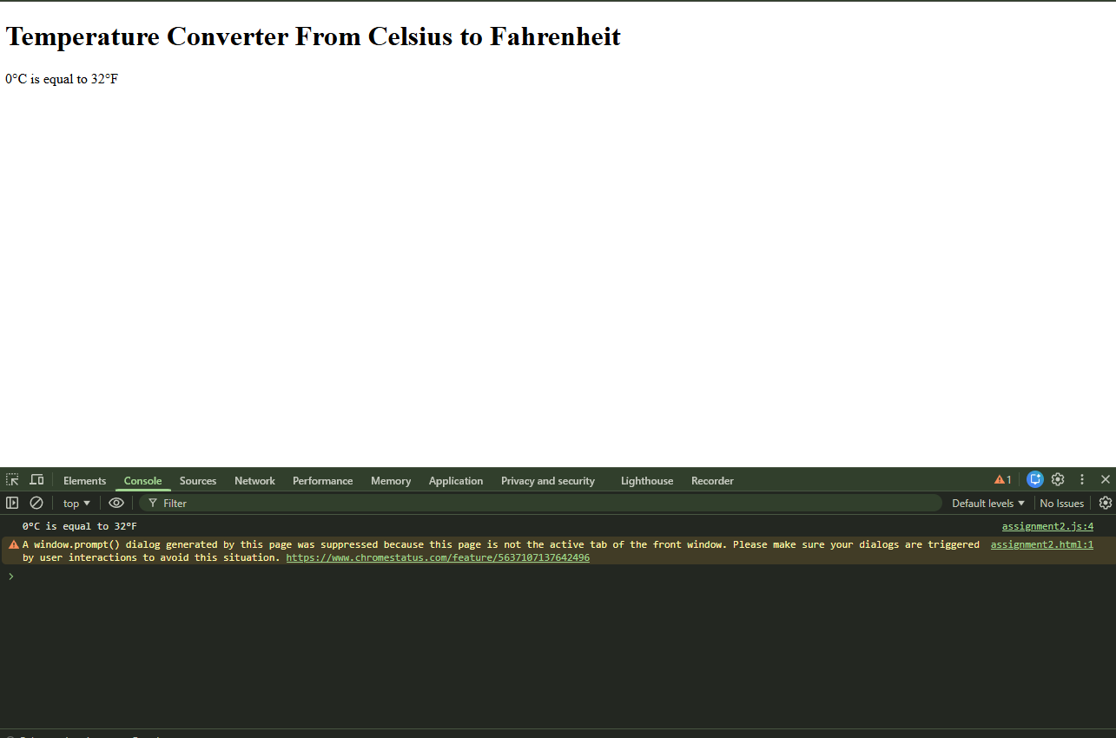
Summary of edits
- Create a HTML file: assignment2.html
- Create the JS file:assignment2.js
- Create a JavaScript program that converts a temperature from Celsius to Fahrenheit.
- Use console.log to output the completed story to the console.

